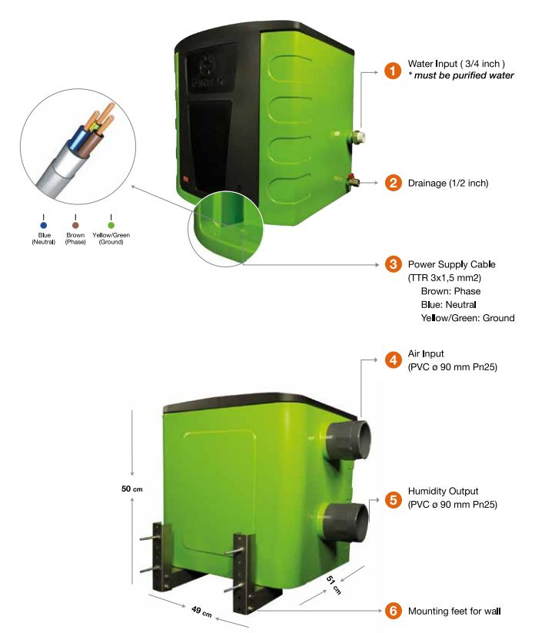

**Plumbing Connection**

!!! The water must be provided from reverse osmosis system to feed the device. Otherwise, the device will be out of warranty.

1. Clean water connection is made with a ¾’’ PPRC pipe and the pressure reducer together from the 1st point shown in the introductory picture of the device. A slight tightening of the connection sleeve will be sufficient.

2. Drainage connection is made with a ½” PPRC pipe at the point number 2 in the introduction picture of the device.

3. After the connection, while testing the device, the buoy must be flat and the water level must be 4 cm. The buoy should be set this way.



* **After service-maintenance and activating, the water level should be 4cm above the piezzo level as in the picture. The buoy should be set this way.**